Constrained Spline and Tension Spline Interpolation Testing Documentation
（IR Server）

2016年11月16日

Credit and Derivative Trading Division

みずほ証券株式会社

Introduction
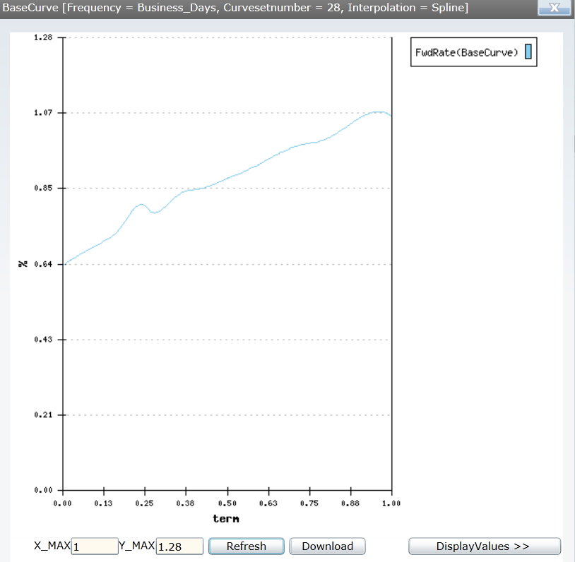
On March 14th, 2016 it was discovered by the New York offices that there were unexpected increasing and decreasing forward values in the 3 Month Libor curve used for interest rate swap pricing, even when the market rates for Libor, futures contracts, and swap rates used were strictly monotonically increasing. Using the market data on this date, we recreated the 3 Month Libor curve on the US IR server which is shown below.
Figure 1 March 14th, 2016 USD 3 Month Libor Forward Curve
We can see that there was a sharp increase and then a decrease when the term was 0.25. The reason for this phenomenon was because of the overshooting of the spline method used in the forward interpolation. There were various attempts to fix this problem. The first attempt was to insert linear interpolated calibration points in between the Eurodollar future contracts up until the first year in this report this method will be referred to as the Tension spline. In this paper, if it is not specifically stated otherwise, we will also assume that the linear interpolated points are inserted daily in between the first 6 three month future contracts, even though 8 three month future contracts are used under the US IR server. We will also define the tension points, being the inserted linear interpolated points, and the tension period being the period were tension points are inserted. The second attempt was to change the cubic spline method into a constrained spline method to prevent the overshooting. The purpose of this report is to document the testing of both methods, and to decide on an appropriate method to use based on the test results.
Cubic Spline Interpolation
The interpolation logic that is currently used in the IR server is the cubic spline interpolation. This section will be devoted to introduce the logic of the cubic spline interpolation. We can first consider a set of points ($x_{0},y_{0}),\left(x_{1},y_{1}\right),\left(x_{2},y_{2}\right),…\left(x_{i-1},y_{i-1}\right),\left(x_{i},y_{i}\right),\left(x_{i+1},y_{i+1}\right),…(x_{n},y_{n})$ and in our case of application for yield curve construction, x would be the time, and y would be the market rates. Let’s first consider the three points$\left(x_{i-1},y_{i-1}\right),\left(x_{i},y_{i}\right),and \left(x_{i+1},y_{i+1}\right)$. Under cubic spline interpolation, we create a third order polynomial in between each point, therefore in terms of these three points, we would be creating two separate third order polynomial functions, one between $\left(x_{i-1},y_{i-1}\right),\left(x_{i},y_{i}\right)$ and one between $\left(x_{i},y_{i}\right), \left(x_{i+1},y_{i+1}\right)$.
This third order polynomial would take the form of the equation below.
$$f_{i}\left(x_{i}\right)=a_{i}+b_{i}+c_{i}x^{2}+d_{i}x^{3} (1)$$
$$f_{i+1}\left(x_{i}\right)=a_{i+1}+b_{i+1}{+c}_{i+1}x^{2}+d_{i+1}x^{3} (2)$$
Both functions meet at the known point $\left(x_{i},y_{i}\right)$ therefore we have the following condition.
$$f_{i}\left(x_{i}\right)=f_{i+1}\left(x_{i}\right)=y_{i} (3)$$
Under Cubic Spline Interpolation, at this known point of intersection the first order derivative and the second order derivative for the two functions are equal to each other therefore we have the following equations.
$${f'}_{i}\left(x_{i}\right)={f'}_{i+1}\left(x_{i}\right) (4)$$
$${f''}_{i}\left(x_{i}\right)={f''}_{i+1}\left(x_{i}\right) (5)$$
We extend the above case to all the points that are used in creating the yield curve while we also taken into consideration the border conditions for the end points ($x_{0},y_{0}) and (x_{n},y_{n})$, where the second order derivative at these end points will be
$${f''}_{i}\left(x_{0}\right)={f''}_{i+1}\left(x_{n}\right)=0 (6)$$
The cubic spline interpolation creates an n+1 by n+1 tridiagonal matrix system of equations and solves for each set of coefficients. The cubic spline ultimately creates a smooth curve, however in between the known points there could possibly be overshooting or undershooting which is the main cause of the problems introduced in the prior section.

Tension Spline Interpolation
The Tension Spline is a method to insert linear interpolated points in between known market data points in order to prevent the overshooting and undershooting that is existent in the Cubic Spline. The irregularities that were introduced in the prior section occurred in between the market data for the USD future contracts, therefore the tension spline introduced in this paper will be inserting linear interpolation points between the futures market data in an attempt to prevent overshooting of the yield curve. However it will not be used for other market data such as the swap market.

Constrained Spline Interpolation
The constrained spline is an interpolation method to prevent overshooting. The segments in between each known points are still third order polynomial functions, however the constrained spline relaxes several of the conditions that are required under the Cubic Spline. It first leaves out the requirement that the second order derivative needs to be equal for each known point. The requirement where the first order derivative is equal at known points is still in existence. However the first order derivative will be a specified function shown below.
$${f'}_{i}\left(x_{i}\right)={f'}_{i+1}\left(x_{i}\right)=f'\left(x_{i}\right) (7)$$
$$f'\left(x_{i}\right)=\frac{2}{\frac{x_{i+1}-x_{i}}{y_{i+1}-y_{i}}+\frac{x_{i}-x_{i-1}}{y_{i}-y_{i-1}}} (8)$$
This specified equation is created by assuming the set of linear relationship for x and y shown below.
$$x_{i+1}=x_{i}+h$$
$$x_{i-1}=x_{i}-h$$
$$y_{i+1}=y_{i}+f'\left(x_{i}\right)*h$$
$$y_{i-1}=y_{i}-f'\left(x_{i}\right)*h (9)$$
Once this set of equations is rearranged for solving $f'\left(x_{i}\right)$ the h will be cancelled out and we arrive at the specified equation above. Another condition for this specified first order function is that if the slope changes signs then $f'\left(x_{i}\right)$ will be 0. This equation is used for all intermediate points, however at the end points ($x_{0},y_{0})$ and $\left(x_{n},y_{n}\right)$, using the condition from $(6)$$${f''}_{i}\left(x_{0}\right)={f''}_{i+1}\left(x_{n}\right)=0$$
We arrive at the equations for the first order derivative for the end points
$${f'}_{1}\left(x_{0}\right)=\frac{3(y_{1}-y_{0})}{2(x_{1}-x_{0})}-\frac{f'\left(x_{1}\right)}{2}$$
$${f'}_{n}\left(x_{n}\right)=\frac{3(y_{n}-y_{n-1})}{2(x_{n}-x_{n-1})}-\frac{f^{'\left(x_{n-1}\right)}}{2} (10)$$
Under constrained spline since all the slopes are already known using the specified first order equation above, solving a system of equations will no longer be necessary. In order to find the all the coefficients of the third order polynomial function, we will be using the following equations derived from the specified first order derivative shown above.
$${f''}_{i}\left(x_{i-1}\right)=-\frac{2\left[{f^{'}}_{i}\left(x_{i}\right)+2{f^{'}}_{i}\left(x_{i-1}\right)\right]}{\left(x_{i}-x_{i-1}\right)}+\frac{6\left(y_{i}-y_{i-1}\right)}{{\left(x_{i}-x_{i-1}\right)}^{2}}$$
$${f''}_{i}\left(x_{i}\right)=-\frac{2\left[2{f^{'}}_{i}\left(x_{i}\right)+{f^{'}}_{i}\left(x_{i-1}\right)\right]}{\left(x_{i}-x_{i-1}\right)}+\frac{6\left(y_{i}-y_{i-1}\right)}{{\left(x_{i}-x_{i-1}\right)}^{2}}$$
$$d_{i}=\frac{{f''}_{i}\left(x_{i}\right)-{f''}_{i}\left(x_{i-1}\right)}{6\left(x_{i}-x_{i-1}\right)}$$
$$c_{i}=\frac{x_{i}{f''}_{i}\left(x_{i}\right)-{x_{i-1}f''}_{i}\left(x_{i-1}\right)}{2\left(x_{i}-x_{i-1}\right)}$$
$$b_{i}=\frac{\left(y_{i}-y_{i-1}\right)-c_{i}\left({x^{2}}_{i}-{x^{2}}_{i-1}\right)-d_{i}\left({x^{3}}_{i}-{x^{3}}_{i-1}\right)}{\left(x_{i}-x_{i-1}\right)}$$
$${a_{i}=y_{i-1}}_{i}-b_{i}x_{i-1}-c_{i}{x^{2}}_{i-1}-d_{i}{x^{3}}_{i-1} (11)$$
As seen in the equations above, under constrained spline the coefficients for the third order polynomial functions can be solved as long as the first order derivative is specified. This logic has been implemented in the engine, and we will be valuating all three interpolation methods in this report.

Various Interpolation Method Testing Under a 1 Year Period
Using the USD market data for March 14th, 2016 which is when the phenomenon appeared, the monthly forward rates for both the Tension Spline and the Constrained Spline are generated in Figure 2. For comparison purposes, I have also included the results for 3 Month Libor interpolated using RiskVal, Linear Interpolation, and Cubic Spline Interpolation.
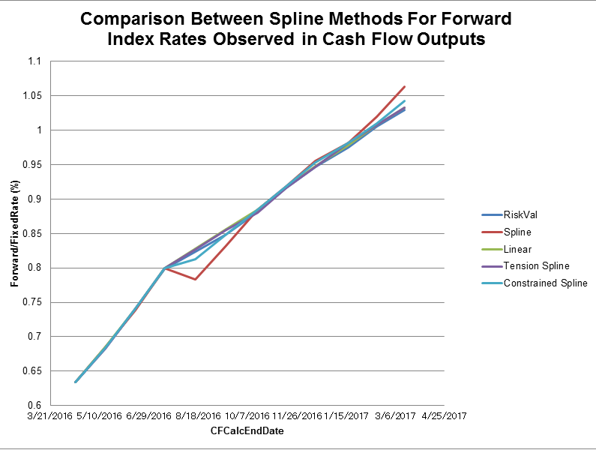
Figure 2 Forward 3 Month Libor Using Various Interpolation Methods

In figure 2 we can see that the sudden increasing and decreasing of the current spline interpolation is very obvious compared to all the other interpolation methods. When just comparing the monthly forward rates it is observed that the Tension Spline interpolated forward values were very similar to the values obtained from RiskVal, as seen by the differences shown in Chart 1.
Pmt Begin | Pmt End | RiskVal | Tension Spline | Difference (bps)
3/15/2016 | 4/15/2016 | 0.63385 | 0.63385 | 0
4/15/2016 | 5/16/2016 | 0.683559 | 0.68351142 | 0
5/16/2016 | 6/15/2016 | 0.740301 | 0.741206702 | 0.09
6/15/2016 | 7/15/2016 | 0.798748 | 0.799916544 | 0.12
7/15/2016 | 8/15/2016 | 0.823789 | 0.82739442 | 0.36
8/15/2016 | 9/15/2016 | 0.848963 | 0.855788226 | 0.68
9/15/2016 | 10/17/2016 | 0.880905 | 0.880446418 | -0.05
10/17/2016 | 11/15/2016 | 0.916356 | 0.916663417 | 0.03
11/15/2016 | 12/15/2016 | 0.946743 | 0.946762974 | 0
12/15/2016 | 1/17/2017 | 0.975443 | 0.981202135 | 0.58
1/17/2017 | 2/15/2017 | 1.006072 | 1.007831369 | 0.18
2/15/2017  Chart 1 Tension Spline and RiskVal Monthly Forward rate Comparison | 3/15/2017 | 1.029986 | 1.033316394 | 0.33

Pmt Begin | Pmt End | RiskVal | Constrained Spline | Difference (bps)
3/15/2016 | 4/15/2016 | 0.63385 | 0.63385 | 0
4/15/2016 | 5/16/2016 | 0.683559 | 0.684273801 | 0.07
5/16/2016 | 6/15/2016 | 0.740301 | 0.741105386 | 0.08
6/15/2016 | 7/15/2016 | 0.798748 | 0.799916544 | 0.12
7/15/2016 | 8/15/2016 | 0.823789 | 0.812661242 | -1.11
8/15/2016 | 9/15/2016 | 0.848963 | 0.848338323 | -0.06
9/15/2016 | 10/17/2016 | 0.880905 | 0.8842859 | 0.34
10/17/2016 | 11/15/2016 | 0.916356 | 0.918613265 | 0.23
11/15/2016 | 12/15/2016 | 0.946743 | 0.953261161 | 0.65
12/15/2016 | 1/17/2017 | 0.975443 | 0.981145238 | 0.57
1/17/2017 | 2/15/2017 | 1.006072 | 1.009646934 | 0.36
2/15/2017  Chart 2 Constrained Spline and RiskVal Monthly Forward rate Comparison | 3/15/2017 | 1.029986 | 1.042570148 | 1.26

Chart 2 shows the values and the differences between the Constrained Spline interpolated forward rates and RiskVal. We can see that both Constrained Spline and Tension Spline monthly forward rates were monotonically increasing therefore suggesting that both methods were able to fix the phenomenon of the irregular increases and decreasing shown during the current spline method. However these results are only valid for a 1 year period, the next sections of this report will analyze the situation for 3 year and 30 year periods.
Tension Spline Testing Under a 3 Year Period
There were no problems in the 1 year period as we have observed in the previous section. However when we set the transaction to a 3 year period with daily frequency, directly after the 1 year period, there were some irregular decreasing and increasing as pointed out in figure 3 below.
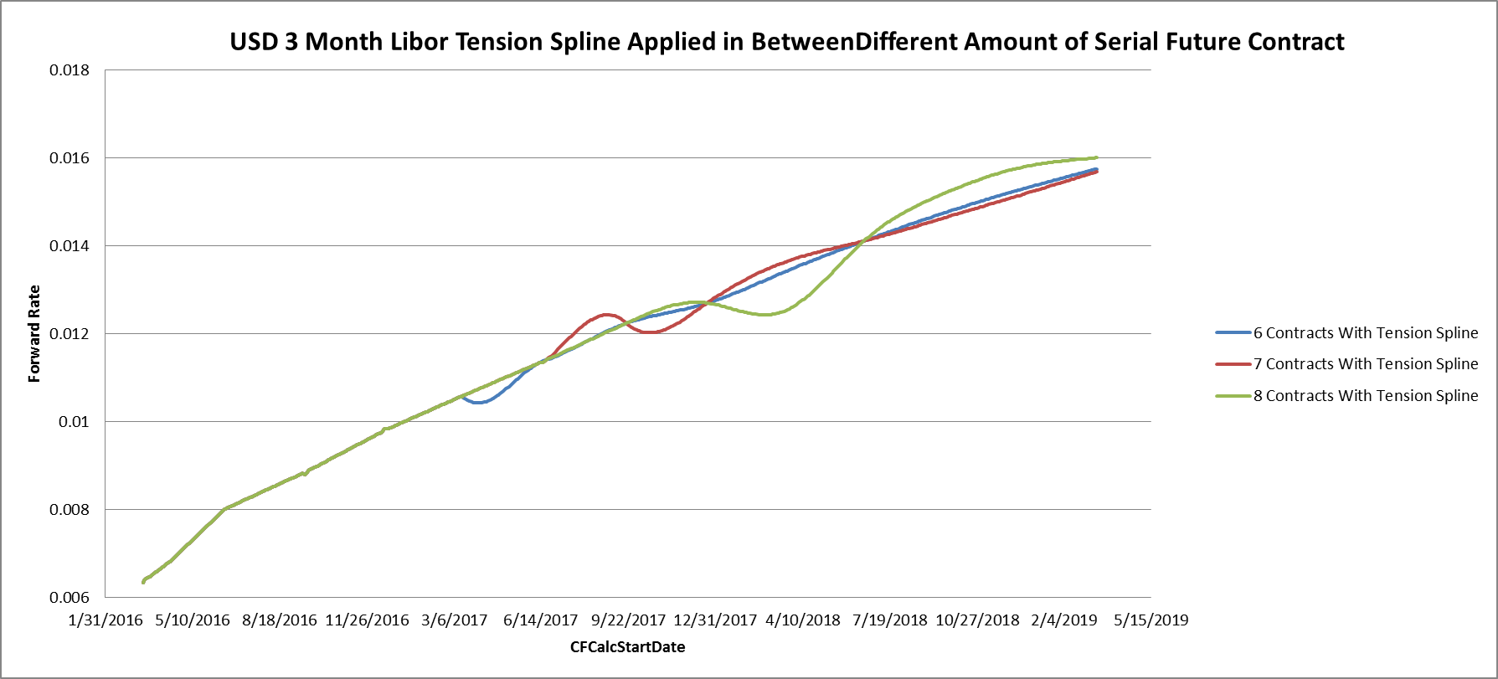
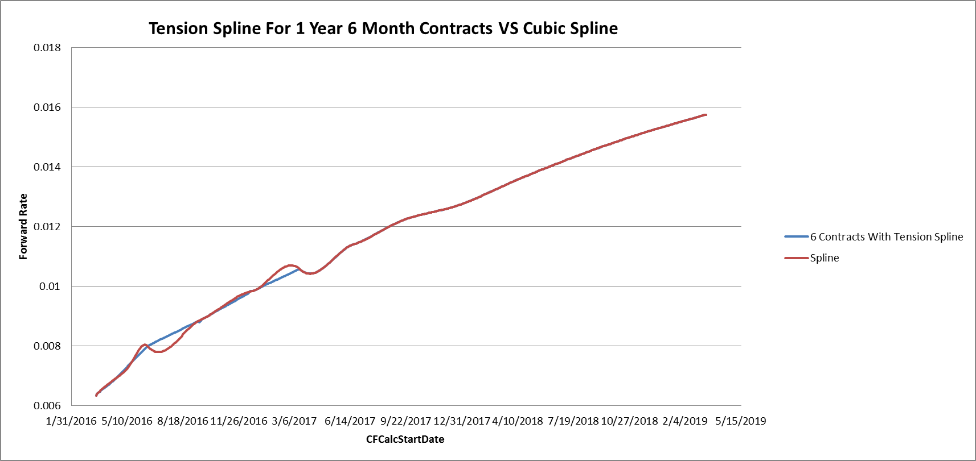
In figure 3 we can see that after the 1 year mark, the blue curve of the tension spline and the red curve of the current spline overlap and both have a sudden decreases and increases. It is mentioned in the introduction that unless otherwise specified the Tension Spline interpolation mentioned in this report will be constructed inserting linear interpolated points daily in between 6 future contracts. The first 6 three future contracts cover 1 whole year. Therefore directly after the period we have inserted tension points, there was a sudden decrease and increase. In order to solve this problem we experimented to extend the tension period to the 7th and 8th future contract, as shown below.
Figure 5 Comparisons with Extended Tension Periods
Figure 3 Comparison between Spline and Tension Spline for a 3 year period

Here we observe a sudden decrease and increase after the tension period
Figure 5 shows a comparison between the tension periods for 6, 7 and 8 future contracts. We can observe in all three situations that directly after the tension period when we are reverting to the cubic spline method, there was irregular increasing or decreasing and this effect was exacerbated even when we increase the contracts to 8 contracts. The reasons are due to the fact that there was a sudden change in the tenor of the market data used. For example directly after the 8th futures contract the data that is used to construct the forward curve will be the swap rates where the market data are only available on a yearly base, which is why overshooting effect of the spline interpolation was the worst for the curve that used tension points for 8 contracts in Figure 5. When we only having tension points for the first 6th future contracts, we can use the 7th and 8th future contract to act as a buffer before we use the swap market data, which is the reason why the tension period for the first 6th future contract was the most stable of the three curves shown in figure 5. Nevertheless the Tension spline method was not able to solve our problem completely.

Constrained Spline Testing Under a 3 Year Period
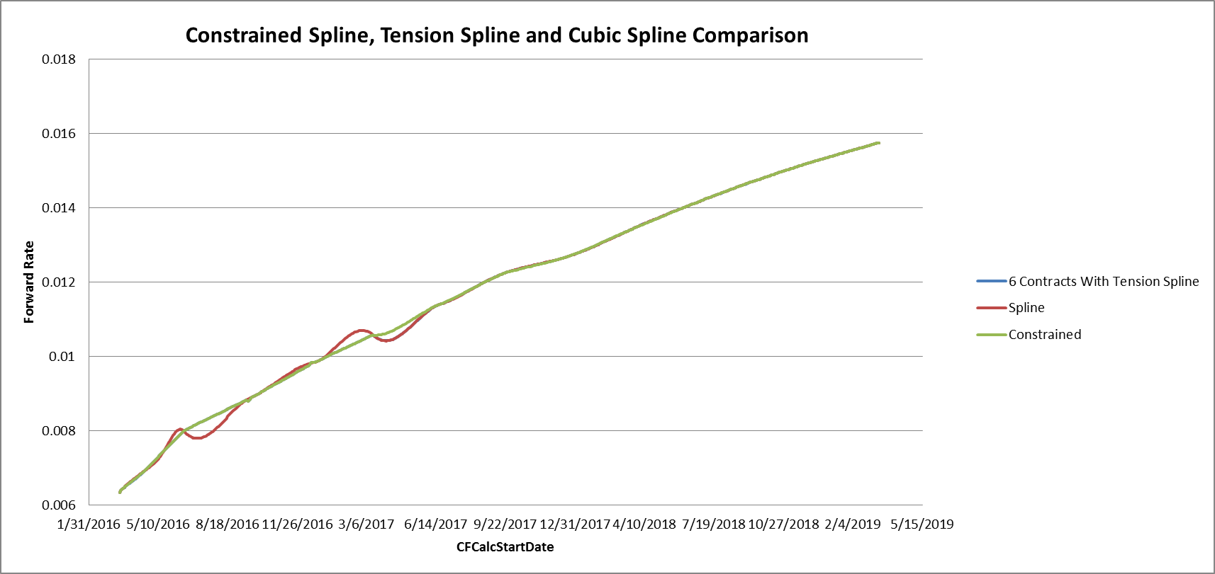
We reran the tests that were applied to the Tension Spline for Constrained Spline interpolation. In the graph below we can see that there is a major improvement when the constrained spline is used for the forward interpolation. Irregularities such as sudden decreases and increases are not observed under the constrained spline. The Tension spline below is also completely overlapped by the Spline and the constrained spline forward curves.
The constrained spline was able to solve the problems that existed within the Tension Spline, where there were irregular movements to the curve directly after the tension period. Therefore we pursed to the next step to check if there were any irregularities under a 30 year period.
Figure 7 Comparisons between Tension Spline, Spline and Constrained Spline
Constrained Spline Testing Under a 30 Year Period
After testing the constrained spline under the 30 year period, we observed that the constrained splines interpolated forward curve overlapped with the spline interpolated forward curve with only improvements in the short term period as seen in the area of the blue circle below.

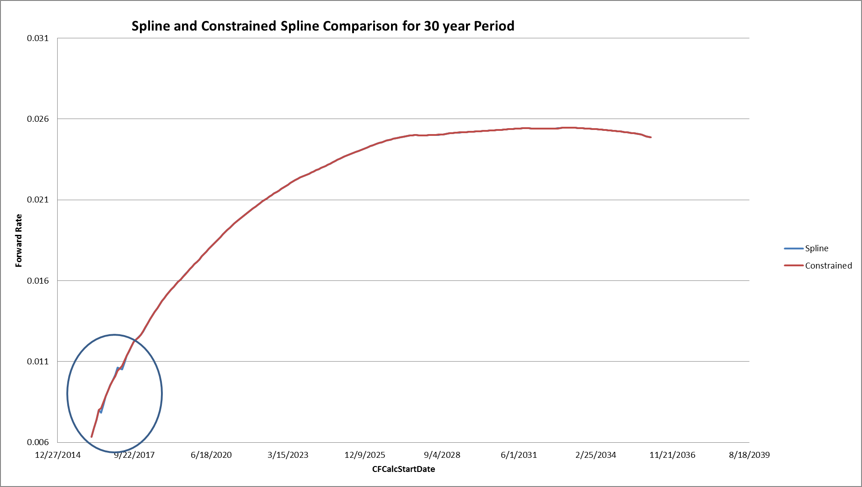
Figure 8 30 Year Period Comparison between constrained Spline and Spline

There seemed to be no problems with using constrained Spline for long term periods as shown in Figure 8, therefore we proceeded to test to see how much of an impact the constrained spline had created for PV calculations, and if there were any problems with using the Constrained Spline method for risk calculations.

Constrained Spline Present Value Impact
Based on the ODMS transactions that were imported for the US IR server we first calculated PV for the currently utilized spline method for forward interpolation and compared these values with the forward interpolation using the constrained spline method. Please do keep in mind that we only changed the interpolation method for forward interpolation while discount factor interpolation was still using the current spline interpolation for both scenarios. For an as of date for July 26th, 2016, it only created a +78 USD dollar impact. For an as of date of August 10th, 2016, the constrained spline method created a -140 USD dollar impact on the whole trade book. On this same day if we also force the discount factors to also be also using the Constrained Spline method, then the PV impact will be +19,191 on the US trade book. Since our major purpose was to fix the problems in the forward interpolated index, it is recommended to only alter the forward interpolation method and keeping the discount factor interpolation to be using the spline method.

Risk Calculations Using Constrained Spline
In order to confirm the validity of our risk calculations, we used a method called Profit and Loss reconciliation. In this method, we multiply the delta by the change in the market rates between two different days. If the delta is based on the market grid, then we multiply each delta by the change in the market rates and take the sum of each of these results. If this result matches with the actual profit and loss, then we could state that the delta that was calculated was accurate. Since the US IR server only has Interest rate swaps, the risk calculations we will take into consideration are the Basis delta for the 1 month 3 month tenor swap, the Interest Rate delta for the USD 3 Month Libor Curve and the USD OIS curve and Theta.

Using profit and loss between the dates August 5th, 2016, and August 8th 2016 for the whole US trade book, we found that the reconciliation results explained 104% of the profit and loss when we used the constrained spline for forward interpolation, while the reconciliation result was103% using the current spline method for forward interpolation. The differences are miniscule therefore showing the validity of using the Constrained Spline for risk calculations.

Conclusion
In conclusion in order to solve the problem of irregular increases or decreases due to the overshooting of the spline interpolation, we are proposing to use the constrained spline interpolation in place of the current spline method for forward index curve interpolation. The reasons for this recommendation is due to the fact that the constrained spline provided more satisfying results than both the tension spline and spline method when we evaluated the curves for short term and long term periods. The constrained spline method eliminates the irregularities in the curve and also provides similar risk calculations compared with the current spline method. We recommend using the constrained spline for the forward interpolation to solve our current problem, but to keep the spline method for discount factor interpolation. This is because the discount factor curve values are monotonically decreasing throughout a 60 year term where the overshooting of the spline method doesn`t occur. Nevertheless, we have tested the situation of using constrained spline interpolation for discount factors and forward interpolation where it created a greater present value impact on the trade book, but a similar profit and loss reconciliation compared to the current spline method.

